Renewable Energy Policies: Built Upon Economics or Thermodynamics?

Objectives: A net energy analysis of the primary energy sources competing to replace depleting fossil fuels will be presented. Results will include:

- A comparison of the net energy (Energy Return on Energy Invested) for conventional and non-conventional fossil fuels, nuclear energy and renewable technologies [Figures 1,2];
- A procedure to impart the discipline of thermodynamic testing to the primary energy solutions competing in the policy arena.

Background: As energy prices rise exponentially and an increasing number of people become aware of peak oil, attempts are being made to revive the nuclear option and to exploit carbon-intensive non-conventional fossil fuels to replace gasoline and other transportation fuels.

Confusion reigns as we watch advocates parade their solutions in front of us, with promises of energy self-reliance based on enormous but geologically challenging reserves sufficient for decades or centuries. Unfortunately, the allegedly promising nuclear option and unconventional fossil-fuel breakthroughs represent potential energetic disasters (e.g., catastrophic fuel shortages) that may overshadow the familiar environmental challenges implied by these options.

There are those who adhere to Adam Smith’s notion that we are led by an invisible hand in a free market. They would assure us that any looming oil shortage will be accommodated by alternative fuels once prices are high enough to justify their exploitation. Candidates include such environmentally daunting energy sources as tar sands, oil shale and the coal-to-liquid process that Hitler used during World War II. When the informed public becomes justifiably skeptical of the greenhouse gases which would accompany these energy technologies, this skepticism in turn is exploited by those eager to promote nuclear power again.

Advocates make claims that rising energy prices create conditions sufficient for their respective solutions to become economical. What these claims overlook, however, is that the profitability test is not immediately subject to the laws of thermodynamics, but rather is the result of political decisions favoring special interests. Greenback energy can be easier to find on paper than green energy on one’s own roof. Thus it has been economical to exploit tar sands in Alberta because natural gas is still cheap there. And yet natural gas equivalent to 1/3 of a barrel is used per barrel for heat to extract oil from the sands. This is in addition to the liquid fuels needed for mining, refining and environmental remediation. (Recognizing rising natural gas prices, advocates are even suggesting nuclear power for heat to replace natural gas in the extraction process.)

Before even considering the potentially devastating greenhouse gas issue, if tar sands were evaluated in terms of thermodynamics, they would flunk the giggle test in a heart-beat. Meanwhile technologies based on solar, wind, water and waves are brushed aside as too intermittent or diffuse to merit serious attention. Yet these renewable technologies are becoming energy gushers – the amount of energy recovered can range from 5 to 50 times the energy invested or beyond, more than sufficient to overcome the round-trip losses associated with energy storage or other valid considerations.

Conclusion: To avoid economic, political and environmental collapse while squandering our remaining fossil fuels, the energetic advantage of renewables must become well understood by policy makers. To secure a sustainable future, it is urgent that a verifiable common measure of thermodynamic efficacy be imposed on competing energy sources and technologies, with policy shaped accordingly. If humanity gets it right, there can be an ecotopian future of clean air and fresh water, viable oceans, thriving rainforests, and peaceful human coexistence.

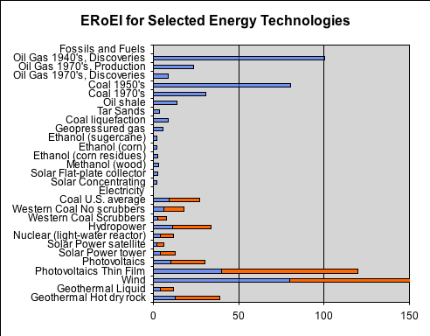

Figure 1
Right-hand bar (electricity) represents allowance of ~10,000 btu/kWh
to address energy quality of electricity relative to direct combustion.
These data may not accurately reflect recent developments and will be revised.
(from Net Energy List (EROEI) Comparing Different Energy Processes from Energy and the U.S. Economy: A Biophysical Perspective by Cutler J. Cleveland; Robert Costanza; Charles A. S. Hall; Robert Kaufmann, Science, New Series, Vol. 225, No. 4665 (Aug. 31, 1984), 890-897)

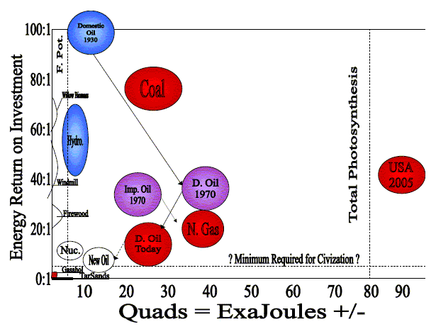

Figure 2
from EROI: definition, history and future implications,
Charles A. S. Hall & Cutler J. Cleveland, ASPO –USA, Denver, November 10, 2005

